## DASHBOARD

The Dashboard offers providers a high-level view of a patient’s clinical picture in an easy-to-read, comprehensive view*. Problems, Encounters, Medications, Reports, Lab Results, Providers, Immunizations,* and *Allergies* are included by default. Items displayed can be configured to match individual user preferences.

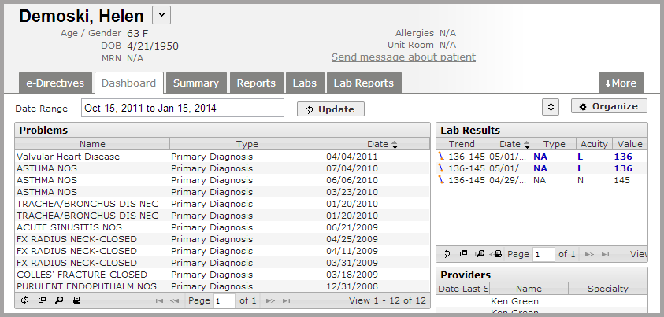

To change the date range, click on the dates displayed. Then, select from the standard options or manually define a date range using the calendars. Finally, click the **Update** button.

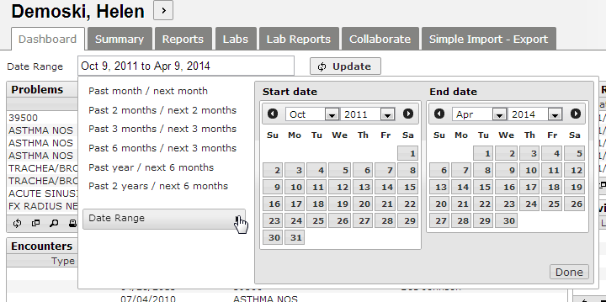

Once a date range is established, each panel will display data bounded by the dates chosen.

### Dashboard Appearance

The size of the rows in each panel can be increased or decreased by clicking on the small double-arrow button in the upper right.

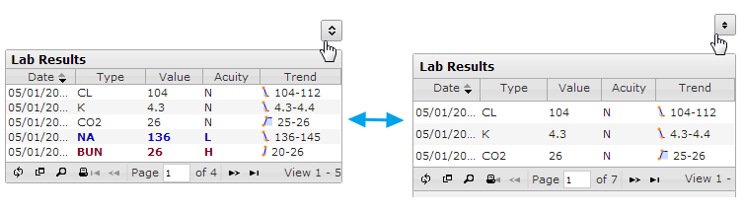

Each individual panel can reloaded, expanded, searched or printed using the icons in the lower left.

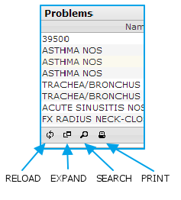

The dashboard panels can be customized by clicking the **Organize** button at the upper right of the screen. Once clicked, the *Panel Options* and *Layout* interfaces will be displayed.

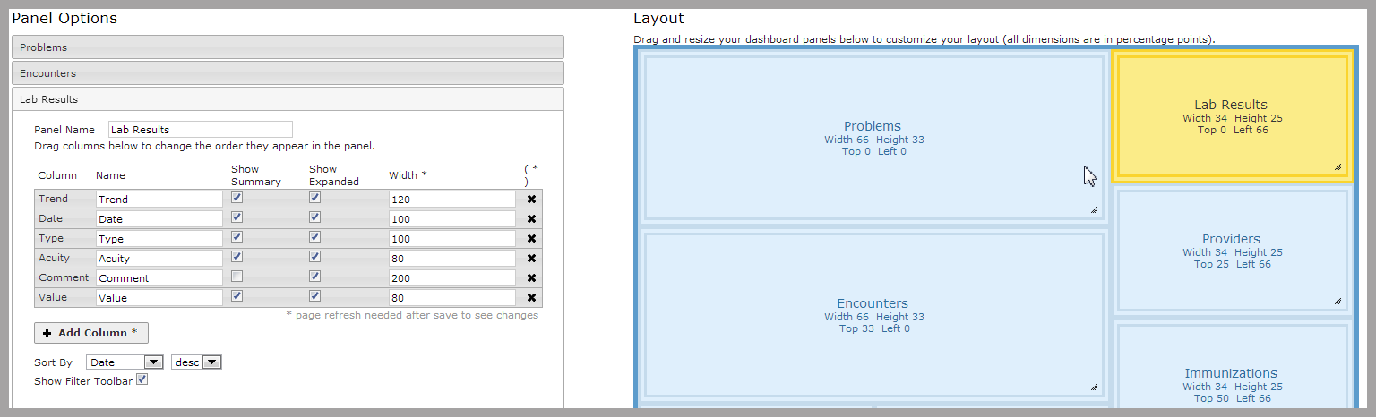

In the *Panel Options* screen, a list of panels titles will be presented. To add a new panel to the dashboard, click the **Add Panel** button and select a panel type from the dropdown menu. To delete a panel from the dashboard, click on the appropriate panel title box and click the **Remove Selected Panel** button.

To edit a panel, click on the panel’s title to expand it:

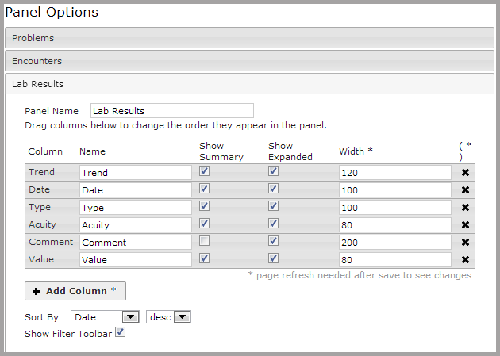

Here, the many of the panel’s properties can be changed:

* The panel name can be changed in the *Panel Name* text box.
* The properties of each column (including name, width and whether the data displayed is in summary or extended format) can be adjusted.
* Column order can be changed by clicking and dragging the column name bar to the desired location.

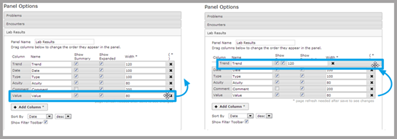

* Columns can be added by clicking the **Add Column** button. Columns can be removed by clicking the **X** at the far right of the column name bar.
* Panel data can be ordered using a specified column in ascending or descending order by selecting options from the *Sort By* dropdown menu.
* Clicking the **Show Filter Toolbar** checkbox will add a toolbar at the top of the selected panel. Typing values into the filter row will select only data that matches that criteria.

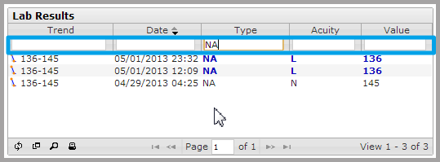

The *Layout* interface allows the dashboard panels to be rearranged and resized. Click and drag a window to change its location on the dashboard. Click and drag on the lower right corner of a panel to resize it.

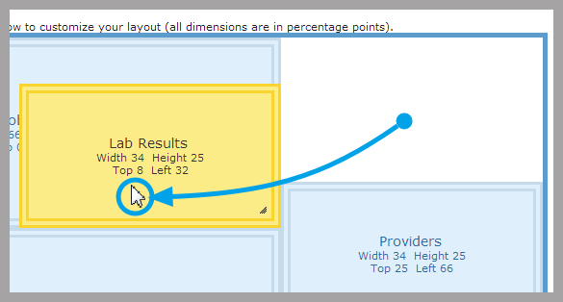 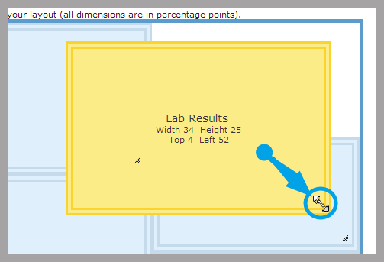

The panels may be positioned such that they will overlap each other in the dashboard. To ensure any changes to the layout have not resulted in overlapping panels, click the **Check Overlap** button. A window will appear if no panel overlaps are present.

When changes to the dashboard panels and layout are complete, click the **Save** button at the bottom of the page. Click **Restore to Default Preferences** to reset any changes. To return to the Dashboard, click **Done.**

### Lab Results Panel

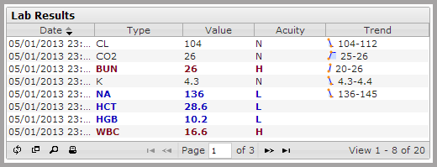

The *Lab Results* panel incorporates a few additional features not found in other panels:

* Hovering over values will display additional information based on the column:
  + The *Value* column will display the units for the lab result value.
  + The *Acuity* column will display the normal value range for a lab result
  + The *Trend* column has two components:
    - A short trend line which will display the individual data point values on the trend line when hovered over.
    - Trend values which will display the most recent values for the lab result followed by the value range when hovered over.

Clicking on a line of data in the *Lab Results* panel will take you directly to that result in the **Lab Reports** tab.

### Reports Panel

Clicking on a line of data in the *Reports* panel will take you directly to that result in the **Reports** tab.